Accessibility Design

Definition
# Source: AI Source: Provided by: [Data Path: Persons Table -> ID Column: 1, Name_En Column: Motasem Essam] -> From: [Chatgpt (GPT‑5 Mini)] on [2/12/2026]
Accessibility Design is a web design technique that ensures websites are usable and accessible to all people, including those with disabilities (such as visual, hearing, motor, or cognitive impairments).

Simple Definition
# Source: AI Source: Provided by: [Data Path: Persons Table -> ID Column: 1, Name_En Column: Motasem Essam] -> From: [Chatgpt (GPT‑5 Mini)] on [2/12/2026]
Accessibility Design = making websites easy to use for everyone, including people with disabilities.

How Accessibility Design Works
# Source: AI Source: Provided by: [Data Path: Persons Table -> ID Column: 1, Name_En Column: Motasem Essam] -> From: [Chatgpt (GPT‑5 Mini)] on [2/12/2026]
• Uses clear and readable text with good contrast
• Adds alt text to images for screen readers
• Ensures keyboard navigation works properly
• Uses proper HTML structure (headings, labels, landmarks)
• Provides captions or transcripts for videos
• Avoids flashing or distracting content
• Supports assistive technologies like screen readers

Purpose of Accessibility Design
# Source: AI Source: Provided by: [Data Path: Persons Table -> ID Column: 1, Name_En Column: Motasem Essam] -> From: [Chatgpt (GPT‑5 Mini)] on [2/12/2026]
• Make websites usable for everyone
• Improve user experience for all users
• Support people with disabilities
• Follow accessibility standards (like WCAG)
• Increase inclusivity and equal access

Advantages
# Source: AI Source: Provided by: [Data Path: Persons Table -> ID Column: 1, Name_En Column: Motasem Essam] -> From: [Chatgpt (GPT‑5 Mini)] on [2/12/2026]
• Inclusive and user-friendly for all users
• Improves overall usability
• Helps meet legal and accessibility requirements
• Enhances SEO (search engines prefer well-structured content)
• Better readability and navigation

Disadvantages
# Source: AI Source: Provided by: [Data Path: Persons Table -> ID Column: 1, Name_En Column: Motasem Essam] -> From: [Chatgpt (GPT‑5 Mini)] on [2/12/2026]
• Requires extra time and effort to implement
• Needs knowledge of accessibility guidelines
• Can increase development complexity
• Requires continuous testing and updates
• May limit some design creativity to maintain accessibility standards

Examples
# Source: AI Source: Provided by: [Data Path: Persons Table -> ID Column: 1, Name_En Column: Motasem Essam] -> From: [Chatgpt (GPT‑5 Mini)] on [2/12/2026]
• Adding alt text like “Red shopping cart icon” to images
• Using high contrast between text and background
• Providing keyboard-friendly navigation
• Adding captions to videos
• Using proper headings (H1, H2, H3) for structure

Difference Between Accessibility Design and Other Techniques
# Source: AI Source: Provided by: [Data Path: Persons Table -> ID Column: 1, Name_En Column: Motasem Essam] -> From: [Chatgpt (GPT‑5 Mini)] on [2/12/2026]
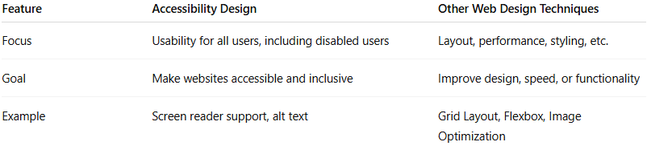
Feature | Accessibility Design | Other Web Design Techniques
Focus | Usability for all users, including disabled users | Layout, performance, styling, etc.
Goal | Make websites accessible and inclusive | Improve design, speed, or functionality
Example | Screen reader support, alt text | Grid Layout, Flexbox, Image Optimization

